**ANICET KABEYA**

**Motherboard**

**Motherboard type:** **Z790-I ROG Strix Gaming WiFi Intel LGA 1700 Mini-ITX**

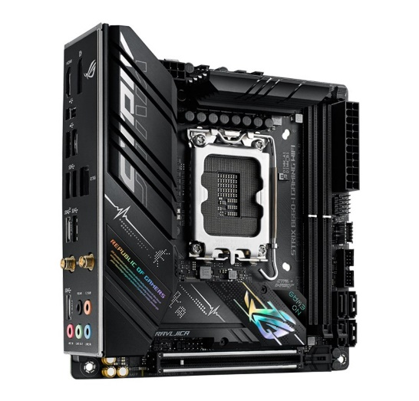**Motherboard information**

**SKU**

522052

**Mfr Part#**

STXZ790-IGMWF

**UPC**

195553947497

**Supported Memory Technologies**

Non-ECC Memory Supported  
Extreme Memory Profile (XMP)

**Maximum Memory Supported Per Slot**

32GB

**Memory Type**

DDR5-4800  
DDR5-5200  
DDR5-5400  
DDR5-5600  
DDR5-5000

**Memory Speeds Supported**

7600(OC)/7400(OC)/7200(OC)/7000(OC)/6800(OC)/6600(OC)/6400(OC)/ 6200(OC)/ 6000(OC)/ 5800(OC)/ 5600/ 5400/ 5200/ 5000/ 4800MHz

**Memory Slots**

2 x 288pin DIMM

**Max Memory Supported**

64GB

**Memory Channel Support**

Dual Channel

**The price: $469.99**

BIOS: 256 Mb Flash ROM, UEFI AMI BIOS

Manageability: WOL; PXE

North Bridge: Intel Z790

Socket Type: LGA 1700

Intel CPU Support: Core i7; Core i5; Core i3; Celeron; Pentium; Core i9